DS.140 Integration Design Specification



PR PaaS Approval Validations Integration

SCM_RICE_361

Author: Pranjul Garg

Creation Date: May 16, 2022

Last Updated: May 16, 2022

Version: 1.0

**Approvals:**

|  |  |
| --- | --- |
| <Approver 1> | <Rakesh Khanna / Naushad / Amit> |
| <Approver 2> | <Business Owner> |

# Document Control

## Change Record

| Date | Author | Version | Change Reference |
| --- | --- | --- | --- |
| 16-May-2022 | Pranjul Garg | 1.0 | No Previous Document |
|  |  |  |  |
|  |  |  |  |
|  |  |  |  |

2

## Reviewers

| Name | Position |
| --- | --- |
| FHL Business | Business User |
| FHL IT Group | Fortis IT Team |
|  |  |
|  |  |

Contents

1 Document Control ii

1.1 Change Record ii

1.2 Reviewers ii

2 Introduction 4

2.1.1 Scope for this Document 4

2.1.2 Intended Audience 4

3 Overview 5

3.1 Business Objectives 5

3.2 Major Features 5

3.3 Glossary 5

4 High-Level HIS to Fusion Integration flow 6

5 Technical Design Details 7

5.1 OIC Services 7

5.2 Oracle PaaS DBCS components 8

5.3 Technical flow 8

6 Data FIELD Mapping 12

6.1 File format 12

6.2 Frequency 12

7 Exception handling 13

7.1 Scenarios 13

8 Assumptions / Considerations 15

9 Open and Closed Issues 16

9.1 Open Issues 16

9.2 Closed Issues 16

# Introduction

### Scope for this Document

This analysis specification document is prepared to layout the PR PaaS approval validation integration.

### Intended Audience

This document is intended for the following groups to provide the action items and consideration that are required to complete the implementation of the various Supply Chain and Finance related functionalities from Oracle Fusion.

#### Fortis Business Users

This document will be helpful for Fortis Business users to understand the technical design and process change with the new structure implemented in Oracle. The business user will validate this document after the verification of the requirement.

#### PwC Technical Team

The PwC technical team will use this document as a source technical design document to develop the technical solution to implement / deploy in Oracle Fusion.

#### Fortis IT Team

The Fortis IT Team must facilitate the PwC technical team for requisite details and other elements required from Business. The Fortis IT team is also responsible to arrange and provide required technical information wherever is required.

# Overview

Fortis Healthcare Limited (FHL) is a chain of hospitals, headquartered in India. Fortis started its health care operations from Mohali where first Fortis hospital was started. Later, the hospital chain purchased the healthcare branch of the Escorts group and increased its strength in various parts of the country. The Fortis health care also operates its hospital in Vasant Kunj, Faridabad, Gurgaon. The FMRI hospital at Gurgaon is the headquarter of Fortis healthcare with all the major facilities at the hospital.

This specification document is prepared to layout the design of PR PaaS approval validation integration. Oracle PaaS DBCS has been used for validating the data before approving the PR from a dummy user.

## Business Objectives

The following are the business objectives.

1. To have a secure, reliable, and scalable design flow to validate all the PRs which are submitted for approval via the PaaS DBCS database.
2. To have a solution providing the monitoring capabilities.

## Major Features

The proposed solution will have the following features involved:

1. A dummy user has been created in Oracle Fusion and configured as a first level approval for all the PRs. Actual business approval hierarchy starts once the given PR is approved from this dummy user.
2. The PLSQL code has been written which fetches the PR which are pending for approval with this dummy user, validates the PR data and finally act accordingly.

## Glossary

REST

Representational State Transfer.

OIC

Oracle Integration Cloud

# High-Level HIS to Fusion Integration flow

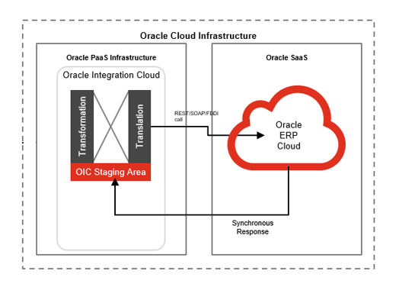

# Technical Design Details

This section describes the technical details of all the components involved in the design of PaaS approval validation integration for PR.

## OIC Services

An App driven orchestration has been designed in OIC to build a REST Endpoint URL, which triggers a PLSQL procedure to process the PRs.

|  |  |
| --- | --- |
| **OIC Integration Name** | Fortis Trigger PaaS App Validation Integration |
| **OIC REST Endpoint URL** | https://oic-prod-nr5lr39yailj-bo.integration.ocp.oraclecloud.com:443/ic/api/integration/v1/flows/rest/FORTI_TRIGG_PAAS_APP_VALID_INTG/1.0/paas/approvalValidation/ |
| **Method** | POST |

Following OIC integration is an exact replica of the above integration, which invokes a PLSQL procedure as a parallel thread to process the PRs in parallel so that bulk PRs can be processed at the same time.

|  |  |
| --- | --- |
| **OIC Integration Name** | Fortis Trigger PR PaaS App Validation Intg |
| **OIC REST Endpoint URL** | https://oic-prod-nr5lr39yailj-bo.integration.ocp.oraclecloud.com:443/ic/api/integration/v1/flows/rest/FORT_TRIG_PR_PAAS_APP_VALI_INTG/1.0/paas/approvalValidation/ |
| **Method** | POST |

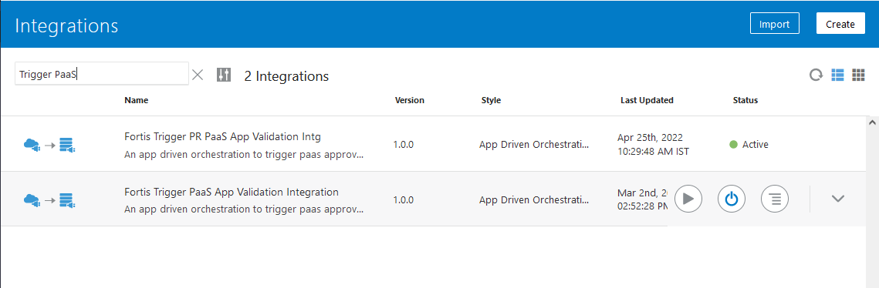

## Oracle PaaS DBCS components

This integration design uses the following components from Oracle PaaS DBCS:

|  |  |  |
| --- | --- | --- |
| **DB Component** | **Component name** | **Details** |
| **Tables** | xxfh_saas_validations_tbl | This is a common table where all the PR/PO/BPA records are stored which are getting processed via the PaaS approval validation integration. |
| xxfh_saas_validations_tbl1 | This is a replica of the above table which was created to enable a parallel thread for processing PRs in parallel. |
| xxfh_wftask | This is BPM task table which contains the details of approval notification with its complete details. |
| **Package** | XXFH_SAAS_APP_VALIDATION_PKG | This package contains a procedure xxfh_validate_pr_prc which basically fetches the PRs which are pending for approval with “Fortis Sysadmin”, validates them and finally approve/reject them. |
| XXFH_SAAS_APP_VALIDATION_PKG2 | This is a replica of the above procedure which was created to enable a parallel thread for processing PRs in parallel. |

## Technical flow

Following is the complete technical flow for this integration design:

1. A common scheduled OIC integration (Fortis Trigger 10m Integration) invokes this PR PaaS approval validation integration at every 10 minutes.
2. Once the OIC integration is invoked, it internally invokes the PLSQL procedure xxfh_saas_app_validation_pkg.xxfh_validate_pr_prc. This procedure has a following master cursor query which fetches the PR pending for approval with “Fortis Syadmin” user.

SELECT wft.tasknumber task_number,

prh.requisition_number trx_number,

prh.requisition_header_id trx_id,

'PR' trx_type

FROM xxfh_wftask wft, xxfh_por_requisition_headers_all prh

WHERE wft.category = 'Purchase Requisitions'

AND wft.taskdefinitionname = 'ReqApproval'

AND wft.state = 'ASSIGNED'

AND wft.workflowpattern <> 'FYI'

AND prh.requisition_header_id IS NOT NULL

AND wft.identificationkey LIKE

'REQ_' || prh.requisition_header_id || '%'

AND wft.title LIKE '%' || prh.requisition_number || '%'

AND prh.document_status = 'PENDING APPROVAL'

AND wft.assignees = p_user_name || ',user'

AND NOT EXISTS

(SELECT 1

FROM xxfh_saas_validations_tbl b

WHERE wft.tasknumber = b.task_number

AND b.trx_id = prh.requisition_header_id

AND b.trx_type = 'PR'

UNION

SELECT 1

FROM xxfh_saas_validations_tbl1 b

WHERE wft.tasknumber = b.task_number

AND b.trx_id = prh.requisition_header_id

AND b.trx_type = 'PR')

ORDER BY prh.requisition_number;

1. The procedure further loops through each & every PR record and validates them as per the following validations.

* You have submitted an emergency PR with a non PH/MC item.
* You have entered the same item twice at line <line_num>, please keep a single line for a given item.
* You have submitted an emergency PR without Supplier batch / Security Gate entry / Invoice details. Please ensure that no emergency PR line is submitted without these details.
* You have submitted an emergency PR with a past date under "Manufacturer Batch Expiry Date" at PR line level. Please ensure to have a future date in this field.
* You have submitted an emergency PR which has "Manufacturer Batch Expiry Date" within 7 days at the PR line level.
* Please select non-consigned items only in an Emergency PR.
* Valid Consignment Agreement missing for a consigned item at line <line_number>.
* Please select Destination Type as Inventory for DTH Deliver-to-Location.
* You have submitted a PR Capex procurement without a project code. Please ensure that a valid project code is used for the PR line for Capex procurement.
* You have submitted a PR with a project code for Non-Capex item procurement. Please ensure that no project code is used for the PR line for Non-Capex procurement.
* You have submitted a PR for OP procurement. As per the roles assigned, you are not eligible to raise PR for OP Pharmacy procurement. Kindly ensure the correct selection of location on the PR

1. Once a PR is validated from all the above validations, it invokes procedure xxfh_saas_app_validation_pkg .xxfh_call_approval_api to take action on the BPM approval task for the given PR.
2. This procedure invokes Fusion BPM REST API via the apex_web_service.make_rest_request function.

**The Changes were made in Technical and Functional parts of the system. Same has been mentioned below.**

## Technical Changes

* Item Codes will be pre-defined as part of setups and only these item codes will be allowed for consigned PR creation.
* PR line and header amount should not be greater than 55000 (inclusive tax).
* PR should not be created with other PH and MC item codes - Excluding these consigned items - MC0323238, MC0323238, MC0323238, MC0323238.
* PR should not be created with other NM and SV item codes - Excluding these consigned items - MC0323238, MC0323238, MC0323238, MC0323238.
* PR should not be created with Manufacturer Batch Expiry Date for “Consigned PR” within 7 days.
* PR should not be created with Future Security Inward Date
* PR should not be created with Future Invoice Date
* PR should not be created with ASL not mapped item.
* PR should not be created without checking the “Emergency Purchase Order Number required” flag on the PR header.
* PR should not be created with unit Batch MRP less than unit EPR.

**Note:** All the technical changes were made to the saas_app_validation_pkg2 has been migrated. Code has been attached below.

CODE - (All the changes are mentioned under version 3.0)

## Functional Validations

* PR Line type should be ‘Consigned.’
* Item description is not updatable as per latest changes and will be captured in Manufacturer Batch Number / Item Description field and will be entered by the user at the time of PR creation.
* Following mentioned fields will be required to be entered by the user at the time of PR creation:

1. Line Type
2. Item
3. Quantity
4. Supplier
5. Supplier Site
6. Manufacturer Batch Number / Item Description
7. Manufacturer Batch Expiry Date
8. Batch MRP
9. Security Inward Number
10. Security Inward Entry Date
11. Invoice Number
12. Invoice Date

* PR line amount should not be greater than 55,000 (including taxes).
* PR header amount should not be greater than 55,000 (including taxes).
* The items should stockable.
* The items should be assigned to category: “MEDICAL CONSUMABLES.IMPLANT.TRAUMA IMPLANT.NOT TO BE USED.FOR REGULAR ITEM.MISCELLANEOUS.MISCELLANEOUS.YES”.
* The Approval amount limit will be inclusive of the tax amount.
* PR should not be created when user don’t have JOB_CONSIGNED_REQUESTER role.
* PR should not be created without submitting Manufacturer Details.
* Custom lookup creation, will be created as below:

|  |  |  |  |  |  |
| --- | --- | --- | --- | --- | --- |
| **Lookup Type** | **Meaning** | **Description** | **Module** | **Lookup Configuration level** | **REST Access Secured** |
| XXFH_CONSIGNED_PR_LIMIT | XXFH_CONSIGNED_PR_LIMIT | PR Limit for Consigned Items (Trauma) | Purchasing | User | Secure |

Custom lookup Code: This will maintain the approval limits for PR line and PR Header level in the fields **‘Description’.**

|  |  |  |  |  |  |  |  |
| --- | --- | --- | --- | --- | --- | --- | --- |
| **Lookup Code** | **Display Sequence** | **Enabled** | **Start Date** | **End Date** | **Meaning** | **Description** | **Tag** |
| PR_Limit_Line_Level | 1 | Y |  |  | PR_Limit_Line_Level | 55000 |  |
| PR_Limit_Header_Level | 2 | Y |  |  | PR_Limit_Header_Level | 55000 |  |

In case of any change the in the approval amount limit in future, business can change the values in the Lookup codes.

* Existing rule of ‘PO-Emergency’ is edited and condition of line type as ‘consigned’ is removed from this rule and new auto-approval rule as ‘PO-Consigned/Trauma’ for line type ‘consigned’ along with no amount condition is created.

**Bug FOUND AND RESOLVED:**

When a Change Order is created and there are duplicate items found, the package didn’t identify all the duplicate items. The first line where the duplicate item was found is shown in the error.

Now, all the lines in which duplicate items are found is shown in the error message. This bug has been resolved in this release. 

**Server details:**

|  |  |  |  |  |
| --- | --- | --- | --- | --- |
| **Server** | **Host name** | **Port** | **Service Name** | **Username** |
| Oracle PaaS DB | 140.238.225.129 | 1521 | PRODPDB1.fhpubsn.fhvcn.oraclevcn.com | XXFH & XXFH_RO |

**Oracle PaaS Table design:**

* + - 1. Table: XXFH_SAAS_VALIDATIONS_TBL

|  |  |  |  |  |
| --- | --- | --- | --- | --- |
| **S.No.** | **Table Column** | **Data Type** | **Length** | **Remarks** |
| 1 | OIC_FLOW_ID | NUMBER | 22 |  |
| 2 | TASK_NUMBER | VARCHAR2 | 50 | Task number for the BPM approval notification |
| 3 | TRX_ID | NUMBER | 22 | requisition_header_id if TRX_TYPE = 'PR' po_header_id if TRX_TYPE = 'PO' or 'BPA' |
| 4 | TRX_NUMBER | VARCHAR2 | 50 | requisition number if TRX_TYPE = 'PR', PO Number if TRX_TYPE = 'PO', BPA Number if TRX_TYPE = 'BPA' |
| 5 | TRX_TYPE | VARCHAR2 | 50 | PR/PO/BPA |
| 6 | ACTION | VARCHAR2 | 20 | APPROVE/REJECT |
| 7 | COMMENTS | VARCHAR2 | 4000 |  |
| 8 | API_STATUS_CODE | VARCHAR2 | 240 |  |
| 9 | API_RESPONSE | CLOB | 4000 |  |
| 10 | PROCESS_FLAG | VARCHAR2 | 1 |  |
| 11 | ERROR_MESSAGE | VARCHAR2 | 4000 |  |
| 12 | CREATION_DATE | DATE | 7 | WHO columns |
| 13 | CREATED_BY | VARCHAR2 | 20 |
| 14 | LAST_UPDATE_DATE | DATE | 7 |
| 15 | LAST_UPDATED_BY | VARCHAR2 | 20 |

* + - 1. Table: XXFH_WFTASK

|  |  |  |  |  |
| --- | --- | --- | --- | --- |
| **S.No.** | **Table Column** | **Data Type** | **Length** | **Remarks** |
| 1 | ASSIGNEES | VARCHAR2 | 4000 | User name with whom the notification is pending |
| 2 | ASSIGNEESDISPLAYNAME | VARCHAR2 | 4000 |  |
| 3 | CREATOR | VARCHAR2 | 4000 |  |
| 4 | ASSIGNEDDATE | TIMESTAMP(6) WITH TIME ZONE | 13 |  |
| 5 | CREATEDDATE | TIMESTAMP(6) WITH TIME ZONE | 13 |  |
| 6 | FROMUSER | VARCHAR2 | 4000 |  |
| 7 | FROMUSERDISPLAYNAME | VARCHAR2 | 4000 |  |
| 8 | STATE | VARCHAR2 | 4000 | ASSIGNED if the notification is pending for approval |
| 9 | TASKNUMBER | VARCHAR2 | 4000 | Unique number of the notification |
| 10 | UPDATEDBY | VARCHAR2 | 4000 |  |
| 11 | UPDATEDBYDISPLAYNAME | VARCHAR2 | 4000 |  |
| 12 | UPDATEDDATE | TIMESTAMP(6) WITH TIME ZONE | 13 |  |
| 13 | WORKFLOWPATTERN | VARCHAR2 | 4000 |  |
| 14 | TITLE | VARCHAR2 | 4000 | Approval notification subject |
| 15 | IDENTIFICATIONKEY | VARCHAR2 | 4000 | Key column which identifies the base transaction for which the notification is pending for approval |



# Data FIELD Mapping

NA

## File format

NA

## Frequency

The PaaS approval validation integration is scheduled to run every 10 minutes.

# Exception handling

There can be various scenarios for an error to occur. This section defines those error scenarios and the exception handling has been done to notify and act accordingly.

## Scenarios

In a tabular format give list of scenarios and exception handling

* If any of the step or node fails within the OIC integration, Global Fault section is configured within this OIC integration to send an OIC error notification with relevant details.
* The email id has been stored in OIC Lookup: Fortis_FaultNotification_EmailAddress_Lookup against the given OIC integration name.
* It also sends a notification every 10 mintes with the details of the PR/PO/BPA which have been processed in the given run. This notification also acts as a confirmation that the integration has been running fine.

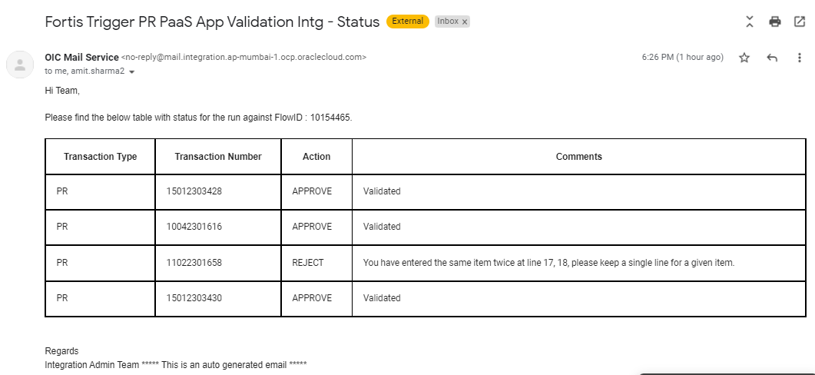

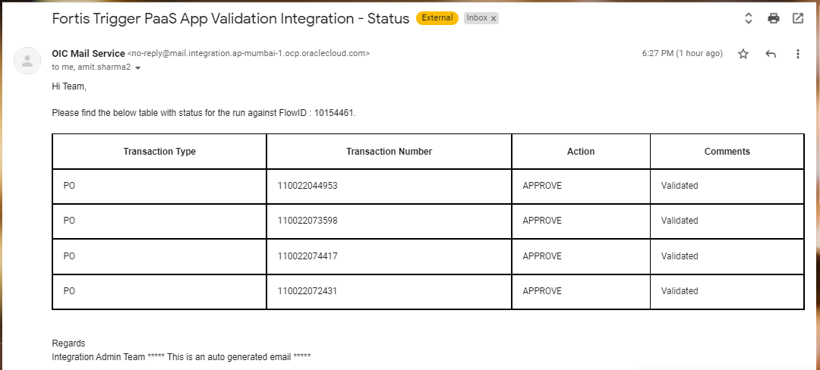

# Assumptions / Considerations

The Proposed Solution will have the following technical considerations.

In the future, if any product bug arises in functionality then this process needs to be revisited after the bug is fixed.

# Open and Closed Issues

## Open Issues

| ID | Issue | Resolution | Responsibility | Target Date | Impact Date |
| --- | --- | --- | --- | --- | --- |
|  |  |  |  |  |  |
|  |  |  |  |  |  |
|  |  |  |  |  |  |
|  |  |  |  |  |  |

## Closed Issues

| ID | Issue | Resolution | Responsibility | Target Date | Impact Date |
| --- | --- | --- | --- | --- | --- |
|  |  |  |  |  |  |
|  |  |  |  |  |  |
|  |  |  |  |  |  |
|  |  |  |  |  |  |